**Vanier College**

**Faculty of Science and Technology**

**Internet Programming**

**LAB 5**

**Multiple Choice. Choose the best answer.**

1. What is the term used to describe image file that contains multiple small graphics?

a. thumbnail image

b. sprite

c. image link

d. viewport

2. Choose the example below of a descendant selector that configures the anchor tags within the element assigned to the content id.

a. #content a

b. .content a

c. a#content

d. content#a

3. The _______ pseudo-class configures the styles that will apply when the mouse is placed over a hyperlink.

a. :hover

b. :click

c. :active

d. :over

4. _________ flow displays the elements on the page in the order they appear in the web page source code.

a. default

b. source code

c. browser

d. normal

5. Use ___________ positioning to slightly change the location of an element in relation to where it would otherwise appear when rendered by a browser.

a. absolute

b. static

c. relative

d. fixed

6. The CSS to create the class called myfloat that floats to the right of the other page content, has a 10px margin, and a solid border is:

1. .myfloat { float:right; margin:10px; border: 1px solid #000000; }
2. #myfloat { right:float: margin 10px; border: 1px solid #000000; }
3. .myfloat { float:right; 10px:margin; border: 1px solid #000000; }
4. .myfloat { float:right; margin:10px; border: on; }

7. Use ___________ positioning to configure the location of an element to remain the same and to not move even when the web page is scrolled within the browser viewport.

a. absolute

b. static

c. relative

d. fixed

8. Use the _______________ property to eliminate the bullets from an unordered list.

a. bullet-image

b. list-style-none

c. list-style-type

d. list-style-image

9. Use ____________ positioning to precisely configure the location of an element outside of normal flow.

a. absolute

b. static

c. relative

d. fixed

10. The _______ pseudo-class configures the styles that will apply when a hyperlink is clicked,

a. :hover

b. :click

c. :active

d. :over

11. If an element is configured with ___________ the other content on the page will appear to its left.

a. position: left;

b. position: relative;

c. float :left;

d. float: right;

12. __________________ will cause an object not to display.

a. display: block;

b. display: 0px;

c. display: none;

d. display: fixed;

13. Use the ________ property along with the left, right and/or top property to precisely configure the position of an element.

1. position: absolute;
2. position: relative;
3. position: float;
4. absolute: position;

14. Use the ________ or _______ property to clear a float.

a. float or clear

b. clear or overflow

c. position or clear

d. overflow or float

15. From the choices below select the correct order to code CSS pseudo-classes.

a. link, hover, visited, active

b. hover, link, active, visited

c. link, visited, hover, active

d. link, hover, active, visited

16. Which value for the display property is useful when configuring horizontal navigation within an unordered list?

a. none

b. block

c. inline

d. fixed

17. Select the example below that could be used to clear a right float.

a. clear: right;

b. clear: left;

c. right: clear;

d. overflow: right;

18. Select the example below that configures a container to clear all floated elements that are within the container.

a. clear: both;

b. overflow: all;

c. overflow: auto;

d. clear: all;

19. Select the property that is useful to remove the underline from a hyperlink.

a. font-style

b. underline

c. text-decoration

d. u

20. The _______ pseudo-class configures the styles that will apply for a hyperlink that has not been visited by the user.

a. :unvisited

b. :link

c. :visited

d. :new

21. When used as a selector in CSS, the _______ character represents the universal selector.

a. #

b. &

c. *

d. /

22. Use the _______ attribute in the HTML link element to associate a web page with a style sheet for printing.

a. media="print"

1. out="printer"
2. media="paper"
3. media="screen"

23. The _______ property configures the stacking order of a positioned element on a web page.

a. z-index

b. stacking

c. display

d. stack

Answers.

1. b

2. a

3. a

4. d

5. c

6. a

7. d

8. b

9. a

10. c

11. d

12. c

13. c

14. b

15. c

16. c

17. a

18. c

19. c

20. b

21. c

22. a

23. a

**Case Study:**

In this case study, you will use “Path of Light Yoga Studio”(Lab4) website as a starting point while you create a new version of the website that incorporates images.

You have the following tasks in this case study:

* Update the “yoga.css” external style sheet
* Update the homepage “index.html” as indicated in Figure 1.

(configure the “Path of Light Yoga Studio” text in header area to be a hyperlink to the home page”index.html”). Also when you scroll the page vertically in the browser window, you should notice the fixed navigation bar.)

* Update the classes page “classes.html” as indicated in Figure 2.
* Create a new Schedule page: “schedule.html” as indicated in Figure 3.
* Add interactivity to hyperlinks

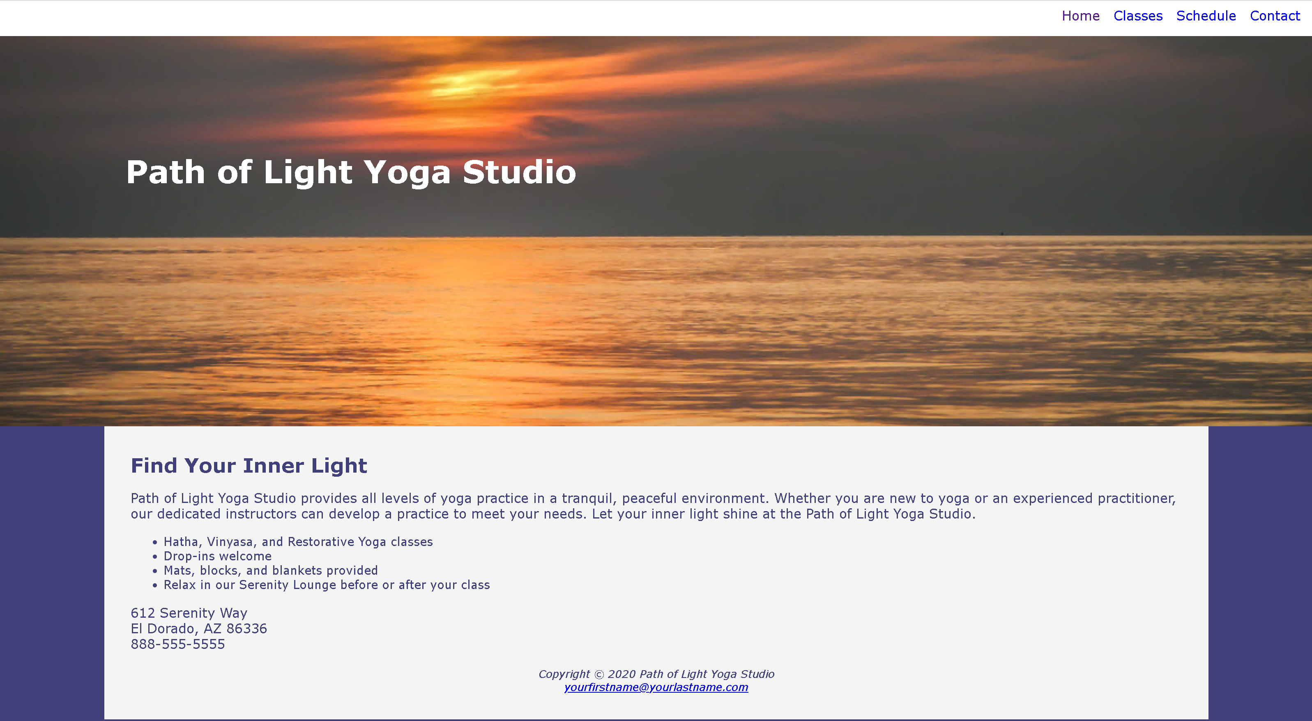

Figure 1: Path of Light Yoga Studio index.html

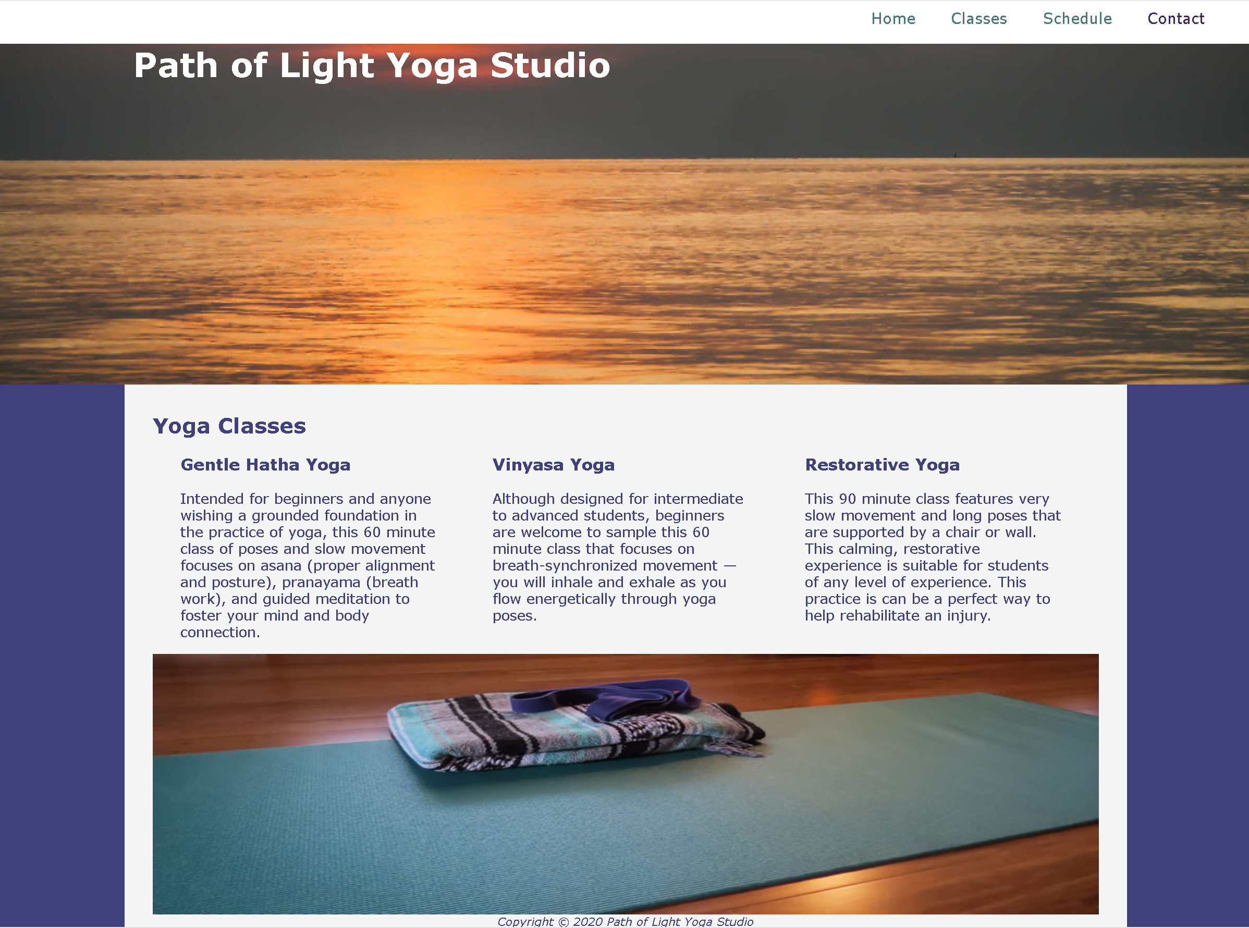

Figure 2: Path of Light Yoga Studio classes.html

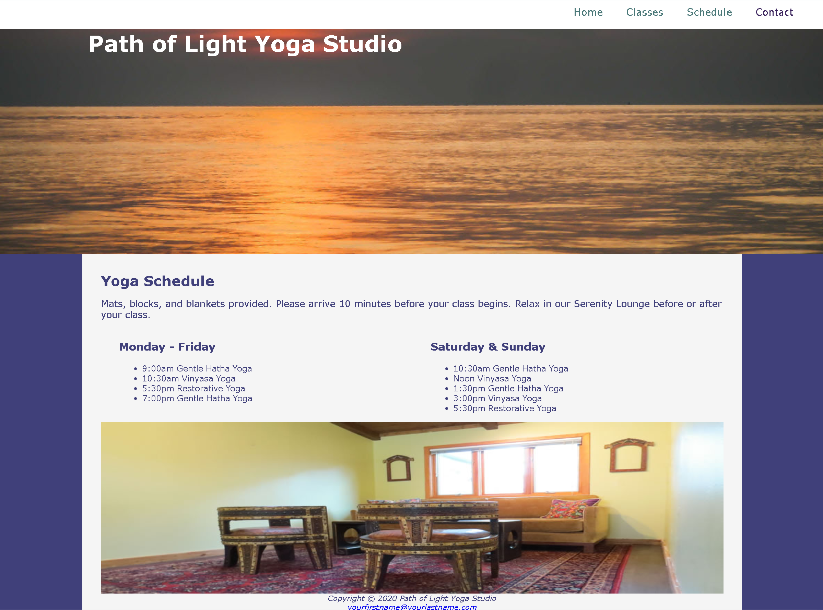

Figure 3: Path of Light Yoga Studio schedule.html